**A Report**

On

**Project Based Learning**

**“SECRET DOOR KNOCK USING ARDUINO”**

Submitted in partial fulfillment of the syllabus

of

**Analog Circuit – II**

**Second Year B. Tech. (Sem-IV)**

**Submitted By:**

Miss. Mohire Shreya Sanjay - 24

Miss. Patil Harshada Mohan - 29

Mr. Pawar Rushikesh Pradeep - 35

Miss. Phadnis Swarada Chandrashekhar – 36

Under the guidance of

**Mrs. G. S. Waichal**



**Department of Electronics & Telecommunication Engineering**

**CANDIDATE DECLARATION CERTIFICATE**

We hereby certify that the work which is being presented in Project Based Learning entitled **“Secret Door Knock Using Arduino”** by Miss. Mohire Shreya Sanjay -24, Miss. Patil Harshada Mohan -29, Mr. Pawar Rushikesh Pradeep - 35 and Miss. Phadnis Swarada Chandrashekhar -36 in partial fulfillment of requirement of the syllabus of Analog Circuit – II Second Year B. Tech. (Sem-IV) submitted to department of Electronics and Telecommunication Engineering, KIT’s College of Engineering, Kolhapur ( Autonomous) is our own work carried out during the period January to April 2019 under the supervision of

Mrs. G. S. Waichal

Signature of the students

Miss. Mohire Shreya Sanjay – 24

Miss. Patil Harshada Mohan - 29

Mr. Pawar Rushikesh Pradeep – 35

Miss. Phadnis Swarada Chandrashekhar-36

This is certified that the above statement made by the candidate is correct to the best of my knowledge.

Signature of Guide Signature of PBL Coordinator

Mrs. G. S. Waichal Mr. Ajay M. Pol

(Assistant Professor) (Assistant Professor)

**ACKNOWLEDGMENTS**

We take the opportunity to express our deep sense of gratitude & respect towards all who helped us to complete our project. We sincerely & humbly express our gratefulness to our guide Mrs. G. S. Waichal and PBL coordinator Mr. Ajay M. Pol & thank him for his valuable support, guidance, encouragement & cooperation without which this project would

not be completed. Last but certainly not the least we extend our gratefulness to teaching & nonteaching staff members of Electronics & telecommunication department & to all our dear friends who have directly or indirectly helped in completion of this project.

Miss. Mohire Shreya Sanjay

Miss. Patil Harshada Mohan

Mr. Pawar Rushikesh Pradeep

Miss. Phadnis Swarada Chandrashekhar

**INDEX**

|  |  |  |
| --- | --- | --- |
| **Sr. No.** | **Name Of The Content** | **Page No.** |
| 01 | Introduction | 06 |
| 02 | Problem statement | 07 |
| 03 | Project Objectives | 08 |
| 04 | Literature Survey | 09 |
| 05 | Circuit Diagram And Working | 10 |
| 06 | Role Of Component | 13 |
| 07 | Discussion | 16 |
| 08 | Application , Advantage , Disadvantage | 17 |
| 09 | APPENDIX 1 | 18 |
| 10 | APPENDIX 2 | 19 |

**INTRODUCTION**

As security is major concern in day to day life the system for the opening and closing of the door became more advanced. But , sometimes elder people unable to understand the advanced tecchoque as well as the physically disabled person may have faced the difficulty in the movement. In this case this system can make their work in easy way.

The secret door knock system includes very simple circuitry. It is very easy to install and operate. After knock , Arduino find knock pattern and save in EEPROM. Arduino decode the knock and compare with the save pattern. If a match occur then Arduino open the gate by driving the servo motor.

**PROBLEM STATEMENT**

* The elderly people or physically disabled people have restriction in movement. The door opening and the closing is quite difficult for them.
* Sometimes accidently the door may lock when people are not in home.
* Latch system may quite difficult for elder people.

**PROJECT OBJECTIVE**

Due to the advance techniques used in opening and closing of the door for security ,this opening and closing operation may difficult to the elderly people and small chores becomes difficult for them. This secret door knock project aims to solve the problems.

After knocking, Arduino finds the knock pattern and save in EEPROM. Arduino decodes the knock and compare with the saved pattern. If match occurs then Arduino open the gate by driving the servo motor.

**LITERATURE SURVEY**

* All about the project :- This system used to make the closing and opening operation in easy manner. To implement this kind of the system there are two options either work on the microcontroller or on Arduino.
* Introduced term:- to overcome the problem of physically disabled person the knocking system more useful. The programming and uploading more easier than burning the microcontroller IC and uploading the program in it. Thus the Arduino used for easy operation.
* Introduction to section of projects:- There are the steps to create opening and closing of the door in smart way. This reports aims to clear many more idea for installation and implementation. Following section works for installation :-
  + - * 1. Uploading of program
        2. Saving knock pattern
        3. Comparing of knock pattern
        4. Give drive to servo motor to open and close the door within certain time period.

**CIRCUIT DIAGRAM**

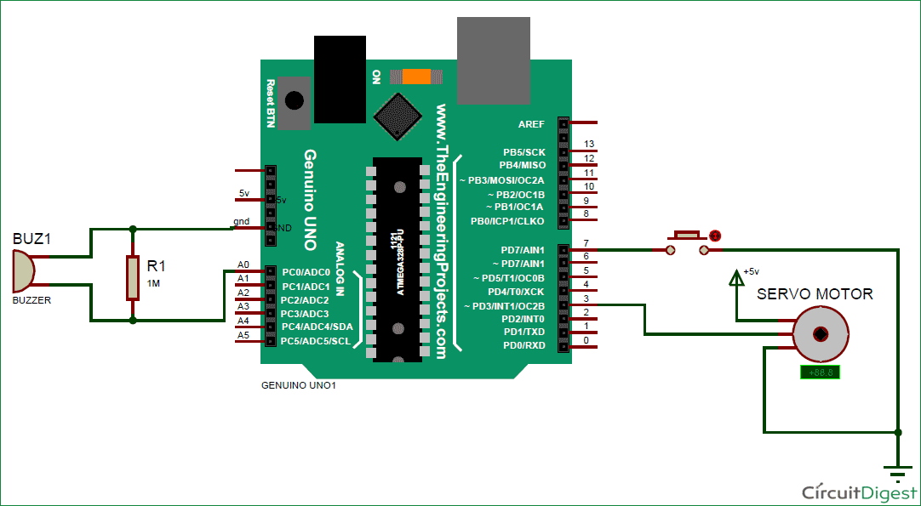

**WORKING :-**

The circuit Diagram of this **Knocking Pattern Detector** is very simple which contains Arduino for controlling whole the process of the project, push button, piezo electric sensor or buzzer, and Servo Motor. Arduino controls the complete processes like taking password form Buzzer or Sensor, comparing patterns, [driving Servo](https://circuitdigest.com/microcontroller-projects/arduino-servo-motor-control-code-and-circuit) for open and close the gate and save the pattern to Arduino.

The push button is directly connected to pin D7 of Arduino with respect to ground. And a **sensor** is connected at analog pin A0 of Arduino with respect to ground and with a 1M resistance between A0 and ground also. A [**Servo motor**](https://circuitdigest.com/article/servo-motor-basics) is also connected to [PWM](https://circuitdigest.com/microcontroller-projects/arduino-due-pwm-tutorial) pin D3 of Arduino.

### Feeding Knocking Pattern in Arduino:

In this circuit, we have used **Buzzer or Piezo Sensor** to take knock input pattern in the system. Here we are using a push button to allow to take input from the sensor and also save that into the Arduino. This system is designed by taking idea from Morse code pattern but not exactly similar with that.

To take input we knock after pressing push button. Here we have knocked by keeping a time period in mind that is 500ms. This 500ms is because we have fixed it in code and input pattern is depending upon it. This 500ms time period will define the input was 1 or 0.

When we knock it, Arduino starts monitoring the time of the first knock to second knock and put that in an array. Here in this system, we are taking 6 knocks. It means we will get 5 time periods.

Now we check the time period one by one. First, we check time period between first knock and second knock if the time difference between these less the 500ms then it will be 0 and if greater than 500ms it will be 1 and it will be saved into a variable. Now after it, we check time period between second knock and third knock and so on.

Finally, we will get 5 digit output in 0 and 1 format (binary).

In short working of **Knock based Smart Lock Project** is simple. First we have to save a pattern in the system. So we have to press and hold push button until we knock 6 times. Here in this project, we used 6 knocks but the user may change it as they want. After six times knock, Arduino find the knock pattern and save that in EEPROM. Now after saving the input pattern, press and immediately released the push button for taking input from the sensor to Arduino to open the lock. Now we have to knock 6 times. After it, Arduino decodes it and compares with saved pattern. If amatch occurs then Arduino open the gate by driving servo motor.

**ROLE OF COMPONENT**

* **ARDUINO :-**

This device is the open source microcontroller board based o the microchip ATmega328p. The operation and programming of this Arduino is very easier than other devices. Pin connection can made easier on the breadboard instead of soldering. Following specification expresses more about why the Arduino used in the door knock system :-

1. Operating range :- 5 volts (e) Input voltage :- 7 to 20 volts
2. Digital pins :- 14 (f) Analog pins :- 6
3. **EEPROM :- 1KB** (g) SRAM :- 2KB
4. Clock speed :- 16MHz

* **PIEZO SENSOR :-**

This sensor is basically used to sense the vibration. Here the vibration of the knock will sense by this piezo sensor. The piezoelectric sensor produces three operational mode.

* + - * 1. Transverse
        2. Longitudinal
        3. Shear
* Shear effect :- The charge produces are proportional to the applied force and independent of the element size and shape.

This sensor is more useful and can operate in easy way. According to the specification of piezoelectric sensor the door knock system becomes more safe and secure . In this project we used sensor of 27mm. Knock pattern given to the sensor and at last it opens the door using servo motor through Arduino i.e. Vibration sensor can harvest otherwise wasted energy from mechanical vibrations. This accomplished by using piezoelectric materials to convert mechanical strain into usable electric energy.

Specifications :-

1. Impedance : <= 500Ω 3. Voltage : <= 30vpp
2. Operating Temp. : -20º to 60º 4. Storage Temp. : -30º

* **1MΩ RESISTOR :-**

This passive element used in this system at analog pins A0.

The resistor in this circuitry used to reduce the current and adjust signal levels.

Specification :- $\frac{1}{4}$ w , 4 carbon films.

* **SERVO MOTOR :-**

This rotary actuator or linear actuator used for control of angular or linear position , velocity and acceleration. This closed loop servomechanism uses position feedback to control the motion and final position. Input to the control signal is digital in this system. The servo motor controlled by PWM (Pulse Width Modulation) . There are the three parts of the servo motor

* 1. Controlled device
  2. Output sensor
  3. Feedback system

In this project the servo motor rotates according to the delay time. If we applied the 1.5ms then pulse will make the motor 90º position. If we applied the time period less than 1.5ms it will rotate to the 0 and if we apply time period more than 1.5ms then the motor will rotates with the 180. Thus we connect the motor to the Arduino at digital side and the time period given is 5ms i.e. greater than 1.5ms.

**Specifications :-**

* Voltage :- 4.8V to 6.0V
* Torque :- 1.5kgf-cm (4.8V) 2.0kgf-cm (6.0)
* Speed :- 0.12 sec/60º (4.8V) 0.10sec/60º (6.0V)
* Weight :- 8.5g ( not include cable and connector 0 9.3g (including cable and connector )
* Size :- 32×11.5×24mm ( include tabs ) 23.5 ×11.5 ×24mm ( not include tab )

**DISCUSSION**

After installing the system we got the following result:-

* In this system the piezo sensor important factor , the vibration and knock pattern received by this sensor and transmitted to the Arduino through resistor.
* If knock matched then the door will open.
* We can install easily this system in the house but the servo motor can be replaced by other motor which can drive our door easily.
* Sensor should placed in proper manner to give the input.
* The time laps between the knock should set in proper way.
* The system can be more improved by using the advanced sensors and WIFI model of Arduino.

APPLICATION

* For the opening and closing of the door in house.
* Used in apartments
* Can be installed in the industries , bank for higher security.

ADVANTAGE

* Easy to operate and install.
* Acquires small space.
* Uploading the program in Arduino more easier than the microcontroller.

DIADVANTAGE

* In this project the security based on the knocking pattern and the sensors. General sensor can detect only the knock pattern this results that door will open if someone knows the pattern.

This problem can solved by using the fingerprint technique. If this system connected to the knocking system it will becomes more secure.

# **Appendix A**

- Itemized Cost Estimate for this Project

|  |  |  |
| --- | --- | --- |
| **Sr. No.** | **Item Description** | **Amount (Rs)** |
| 1 | Arduino UNO 3 | 450/- |
| 2 | Push Button | 3/- |
| 3 | Piezo Sensor | 5/- |
| 4 | Servo Motor | 20/- |
| 5 | 1MΩ Resistor | 2/- |
| 6 | Connecting Wires | 10/- |
| 7 | Serial Communicator Or Power supply | 120/- |
|  | **TOTAL Project Cost (Rs)** | **610/-** |

# **Appendix B**

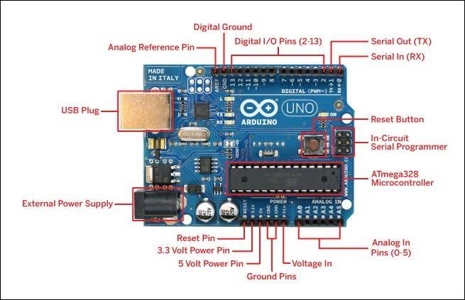

ANALOG PINS :-

* PIN A0 :- This analog pin connected to the one terminal of the resistor. This passive component used for the adjustment in the signal.
* Ground :- The analog pins which are not connected to circuit may create fluctuation. To avoid the fluctuation the analog ground pins are used.
* 5V supply :- This is the general supply given to the circuit. We can give supply from the serial communicator or by 12V supply adaptor.

DIGITAL PINS :-

* PIN3 :- This pin used to trigger an interrupt on a low value , a rising and falling edge , or change in the value. This pin connected to one of part of servo motor.
* PIN7 :- This is the input pin which is connected to the push button.
* PIN13:- At this pin the LED is already placed in Arduino. After uploading the program the on and off moment of LED gives the idea about circuit is working or not.
* Tx and Rx :- These basic pins are used to transmit

**References**

BOOKS :-

* Arduino : A Technical Reference

By : J. M. Hughes

* Beginning Arduino

By : Michael Mcroberts

* 3D Arduino Projects for Evil Genius

By : Simon Monk

* Arduino + Android Projrcts for the Evil Genius

By : Simon Monk

LINKS :-

* [www.arduino.cc](http://www.arduino.cc)
* [www.engineersgarage.com](http://www.engineersgarage.com)
* <https://circuitdigest.com>